**CLAIM MANAGEMENT SYSTEM**

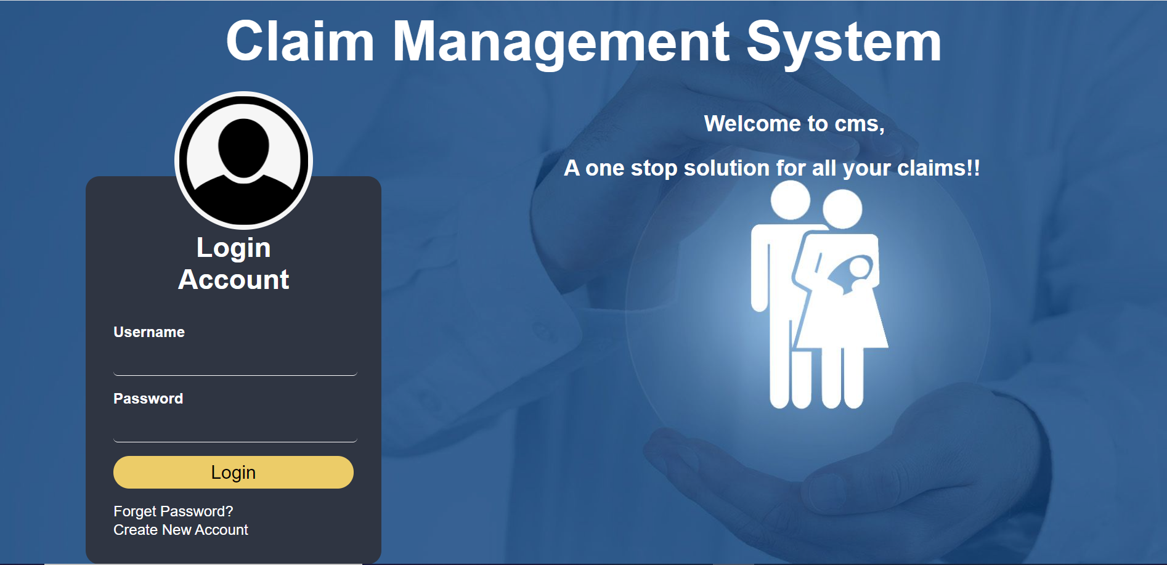

**Diag1.User Login Page**

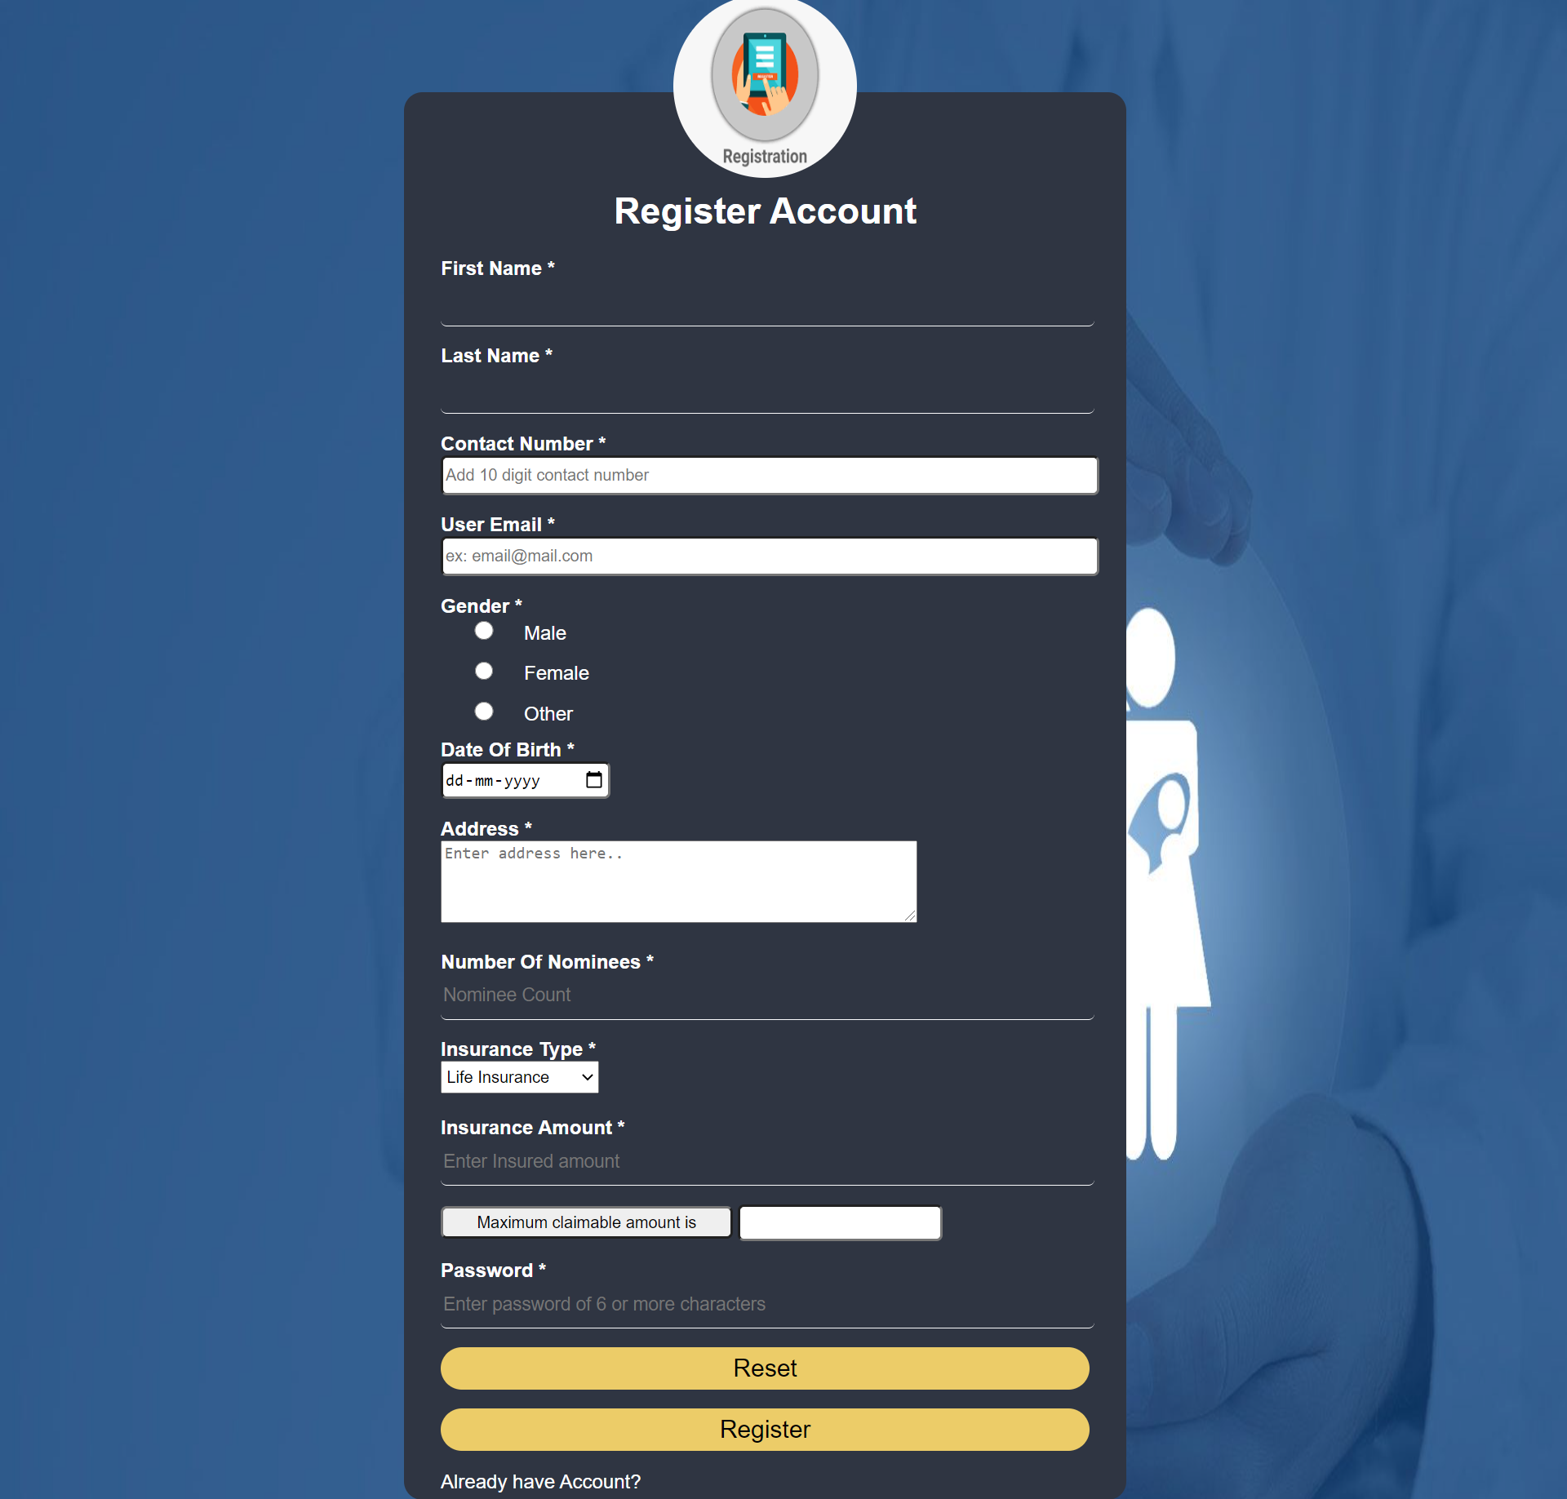

**Diag2.Registration Page of User**

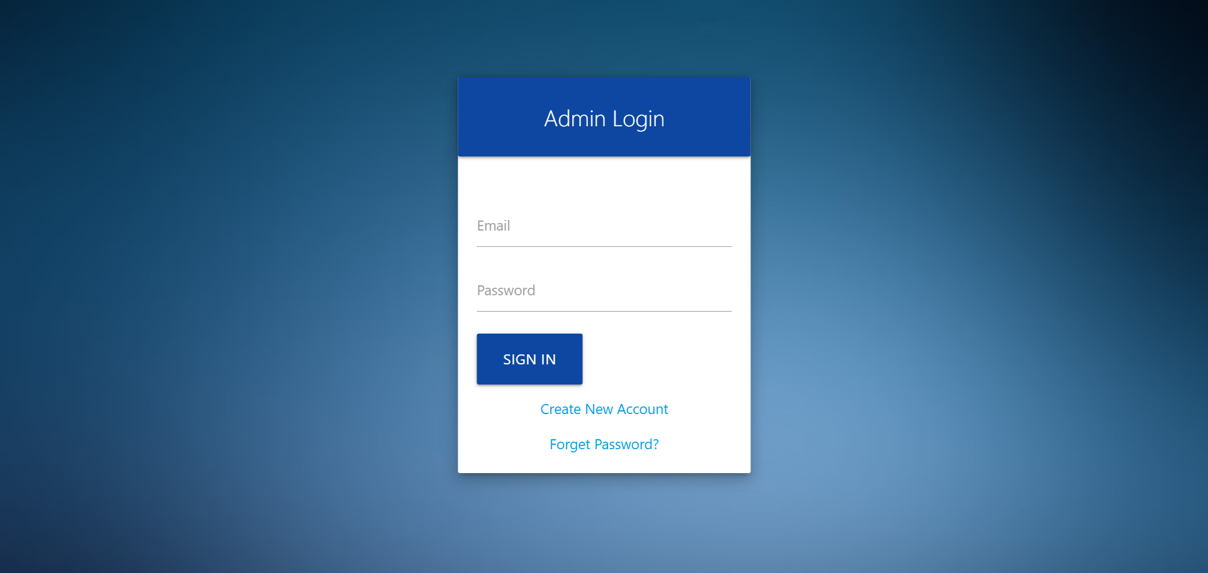

**Diag3.Admin Login Page**

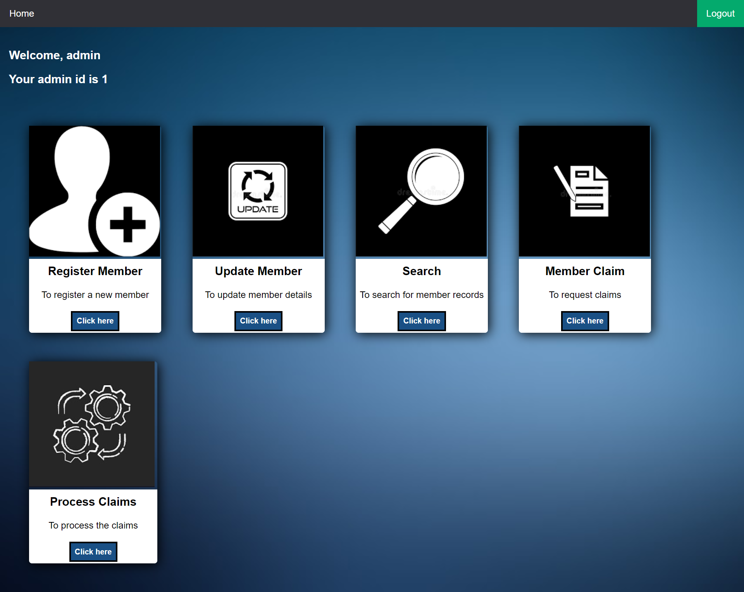

**Diag4.Admin Welcome Page**

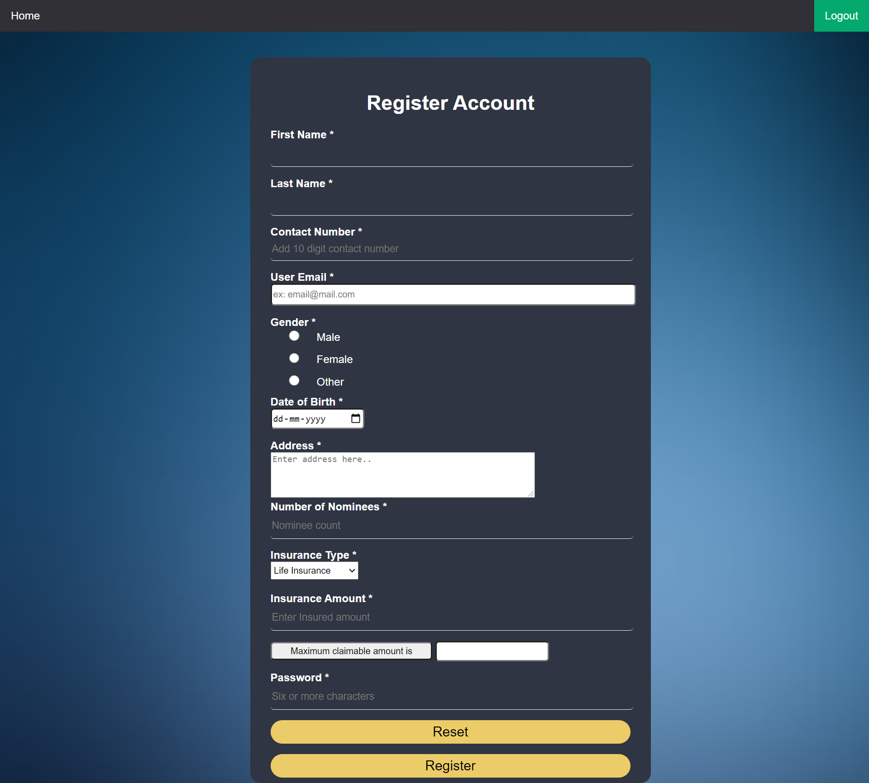

**Diag5.User Registration Page for Admin**

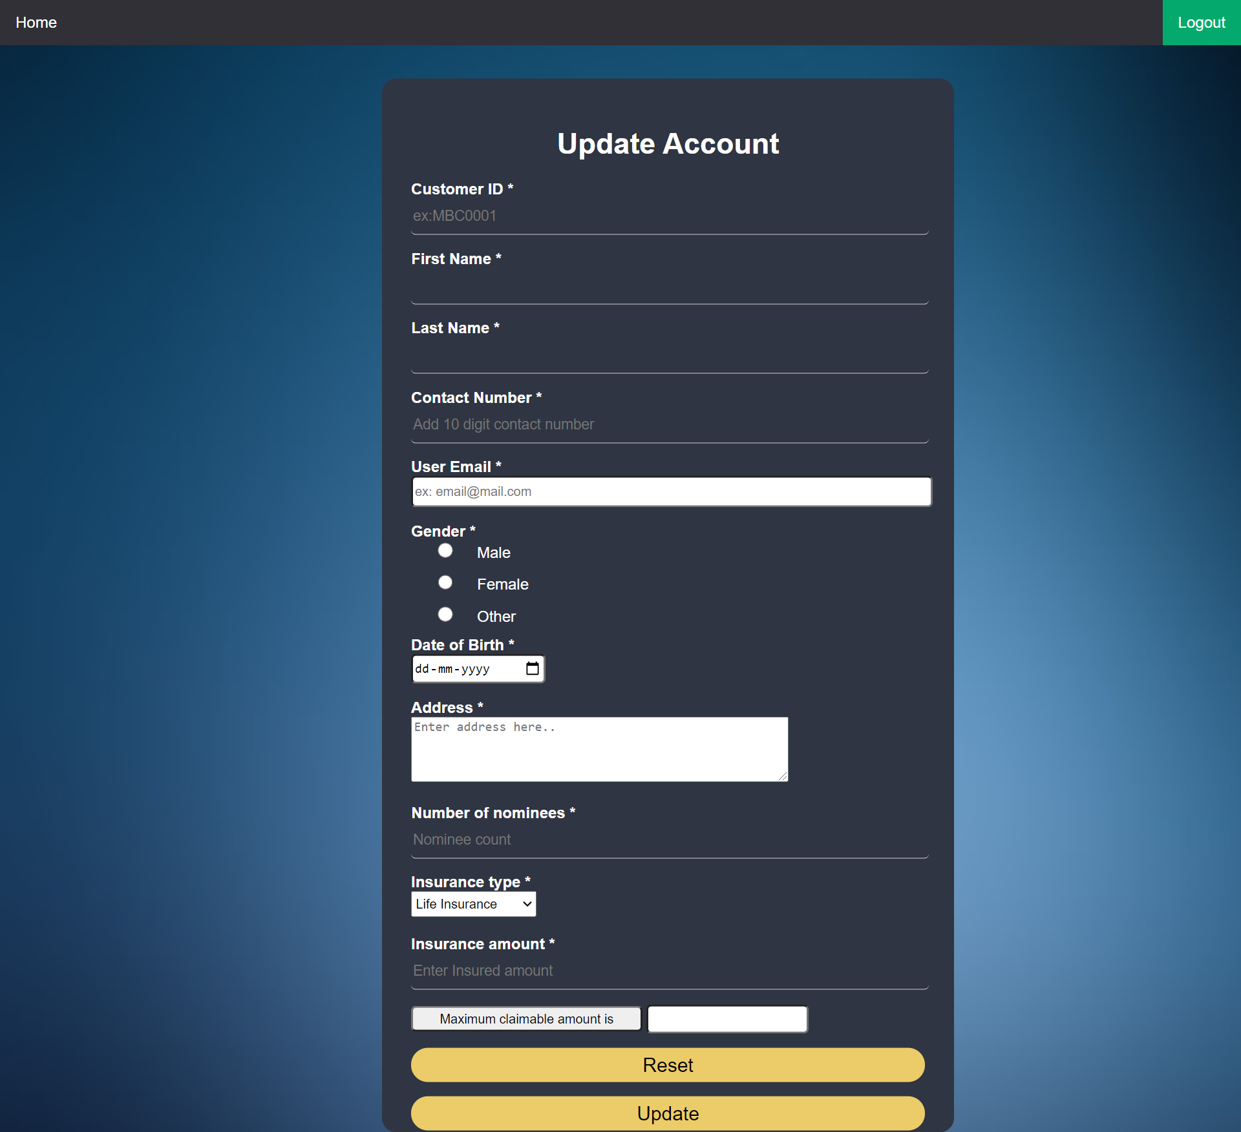

**Diag6.User Update Page for Admin**

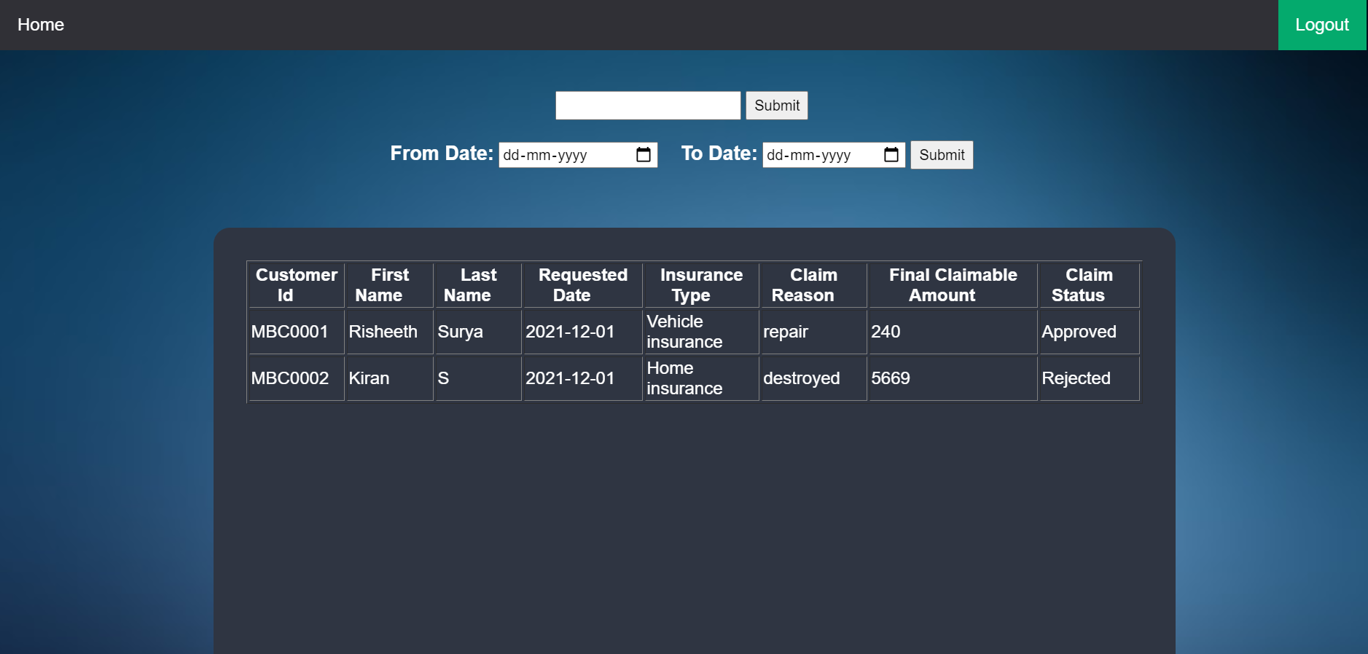

**Diag7.Search Page for Admin**

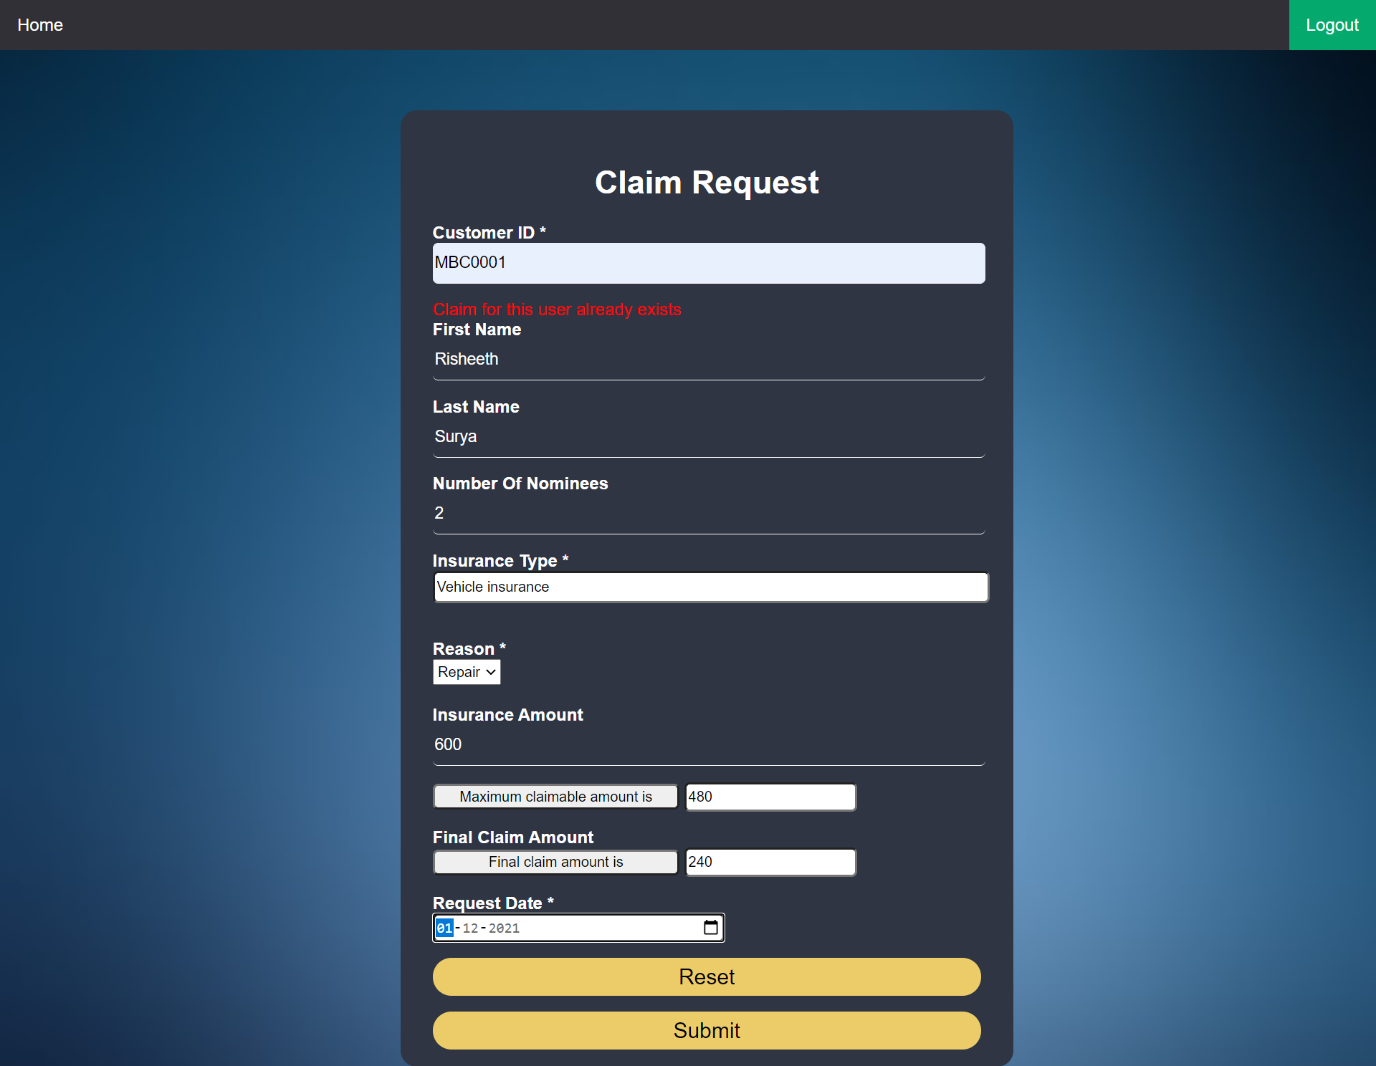 **Fig8.Claim Request Page for Admin**

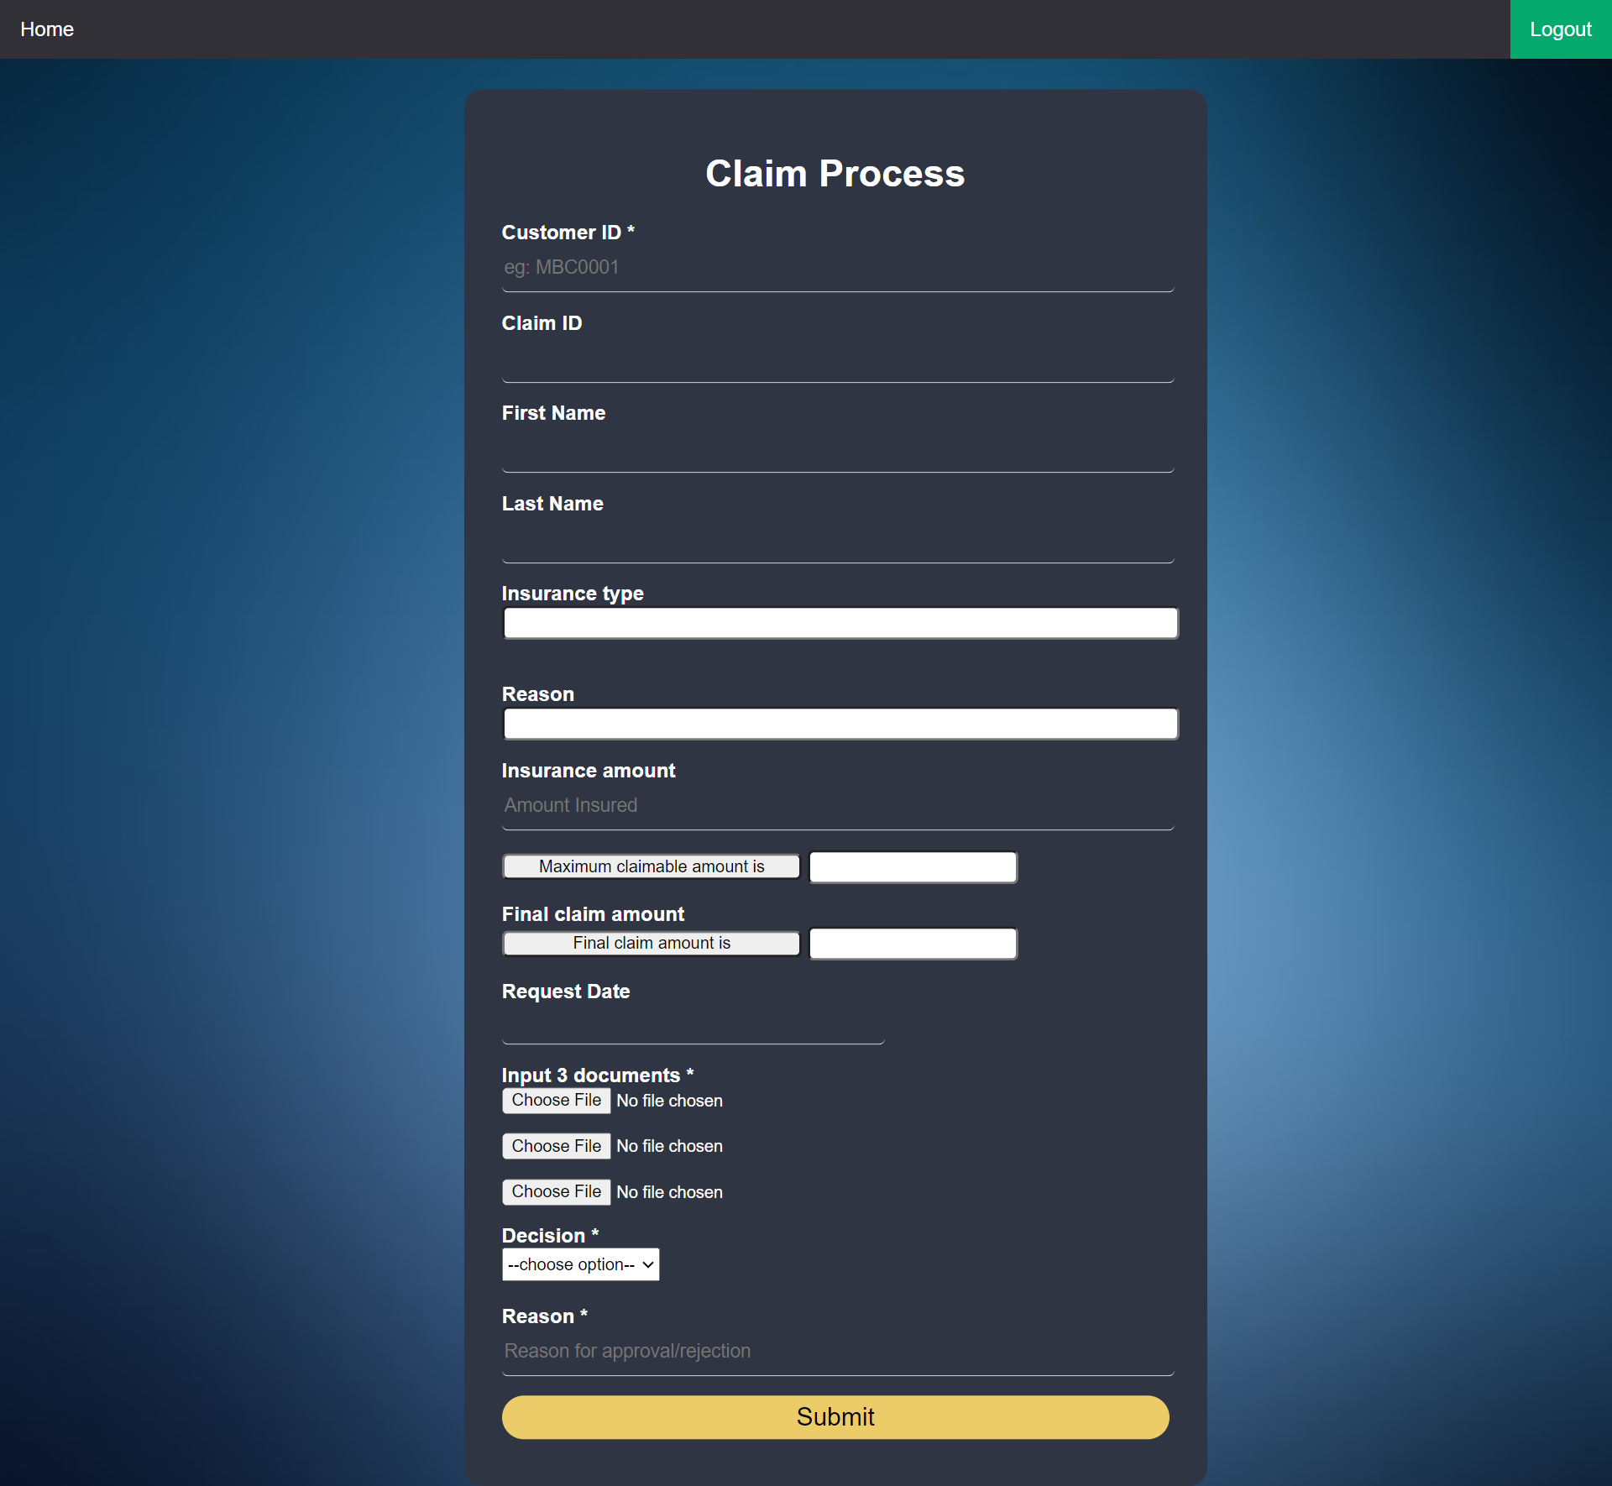

**Fig9.Claim Process Page for Admin**

